

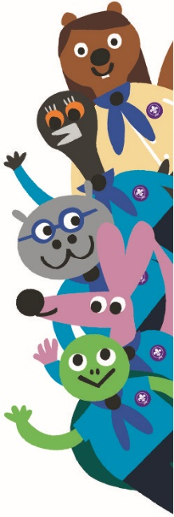
Let’s find out all about becoming a Cub Scout! We hope you will have lots of fun with us and in no time you will be ready to make your promise and become a Cub Scout.
Our Scout Group
Cub Scouts are the third youngest members of the Scout family. In the United Kingdom, Scouts are split into different age groups:

Squirrels: 4 - 5 Explorers: 14 - 18
Beavers: 6 - 8 Young Leaders: 14 - 18
Cubs: 8 - 10½ Network: 18 - 25
Scouts: 10½ - 14 Leaders: 18+

When multiple sections join together, this is known as a Scout Group. There are many different Scout Groups around the world, each with a different name.
Our Scout Group is called .....................................................
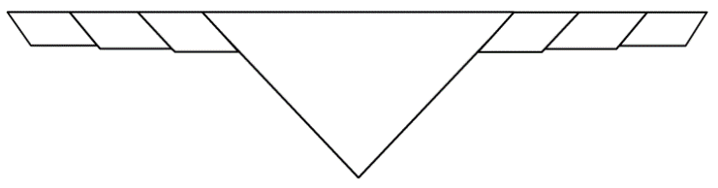
To help tell different Scout Groups apart, each wears a different coloured neckerchief (which some Groups call a necker, neckie or scarf). Colour in the picture below to show what colour our Scout Group wears:
Our Cub Pack
A group of Cubs is known as a Pack. Led by an adult Cub leader traditionally nicknamed Akela after the wise leader of the wolf pack in Rudyard Kipling’s novel, The Jungle Book. Sometimes Packs have their own special name, especially if there are more than one Pack in a Scout Group.
As Packs can be quite big, they are often split into smaller teams known as Six.
I am in the .................................................................Six.
Each Six has a Sixer and Seconder who are chosen to be extra helpful and lead their Six.
The people in charge of the Cub Scout Pack are known as the Leaders. They volunteer their time to help keep you safe and make sure you have lots of fun.
In our Pack, the Leaders are called:
...............................................................................................
...............................................................................................
...............................................................................................

Opening Ceremony
At the start of each meeting we take part in an Opening Ceremony. During this we:
...............................................................................................
...............................................................................................
...............................................................................................
...............................................................................................
Closing Ceremony
When it’s time to go home we do a Closing Ceremony. During this we:
...............................................................................................
...............................................................................................
...............................................................................................
...............................................................................................
At the Closing Ceremony we often give out badges, notices or letters and remind you of anything special you might need next week.
Once Cubs has finished make sure you stay in the hall until an adult has come to collect you. When you leave don’t forget to take your coat, drink and anything you made at Cubs.
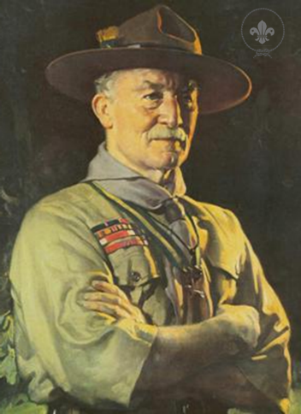
A History of Scouting
In 1907, Lord Robert Baden-Powell held a camp on Brownsea Island to help teach a group of boys some survival and outdoor skills.

This camp helped him write a book called ‘Scouting for Boys’ which was used to start Scouts Groups all around the country.

Originally Scouting was designed only for boys aged 11-18. However, many younger brothers wanted to join Scouts which led to the creation of Wolf Cubs in 1916 and Beaver Scouts in 1986. Wolf Scouts became Cub Scouts in 1966.
For many years only boys were allowed to join Scouts. However, in 1991 Scouting started to accept girls into all sections.
Robert Baden-Powell (along with his wife Olave) also helped to set up a similar organisation for girls known as Girl Guiding.
Both Robert and Olave shared the same Birthday
(22nd February) which in Scouting is now known as Founders Day. This day is a good time to think about all the other Scouts and Guides around the world – there are now around 31 million Scouts in 216 different countries!
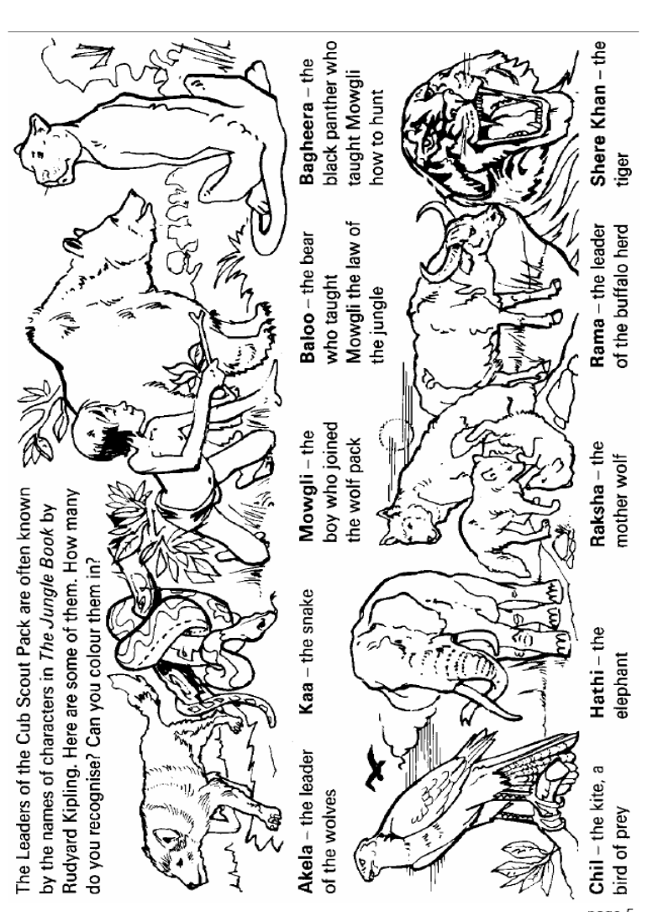
The Cub Pack
Disney has made Jungle Book a household name. Most of us have all heard Baloo singing ‘The bear necessities of life’. But did you know that there is much more to the story than that.

Rudyard Kipling the man who wrote the Jungle Book, was a friend of his. BP liked the Jungle Book stories they were fun and encouraged an interest in nature and outdoor activities. He thought many of the characters were fun and playful, just like Cub Scouts. He also knew it was important for the young people to have a wise leader like Akela, the wolf. Akela lets Mowgli, join the wolf pack. Maybe you also know about Baloo the bear, who helps teach Mowgli the laws of the jungle so he can live among the animals. To this day, we have names like Akela and Baloo, and words like den and pack, in Cub Scouting. That’s our way of remembering how Cub Scouting began with The Jungle Book.

Making Your Promise
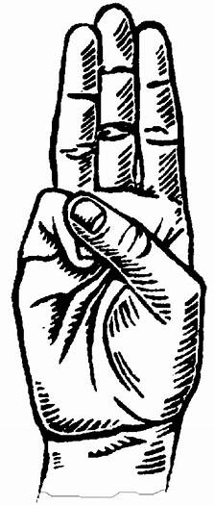
In order to become a Cub Scout you must make your promise at a special ceremony called an Investiture.

You must learn the promise so that you can say it with your friends when you are invested. You will then receive badges to wear on your uniform and the Group neckerchief.
During the investiture you will need to make the Scout sign. In your right hand, use your thumb to press down your little finger like the picture shows.

The Cub Scout Promise

For Christians and those are Jewish
I promise that I will do my best, to do my duty to God and to The King, to help other people and to keep the Cub Scout Law.

For Buddists
I promise that I will do my best, to seek refuge in the Triple Gem, to do my duty to The King, to act with compassion towards all life
and to keep the Cub Scout Law.

For Hindu
I promise that I will do my best, to follow my dharma and do my duty to The
King, to act with compassion towards all life and to keep the Cub Scout Law.

For Muslims
I promise that I will do my best, to do my duty to Allah and then to The King, to help other people and to keep the Cub Scout Law.
For humanists,
atheists and those
with no defined faith
I promise to do my best, to uphold our scout values, to do my duty to the King, help other people and keep the Cub Scout Law.

The Cub Uniform
Each of the Scout sections wear a different uniform so
you can easily tell whether they are a Squirrel, Beaver, Cub, Scout or even a Leader. Once you have decided that you want to become a REAL Cub Scout you should buy a bottle green jumper ready for when you make your promise.
Badges
Once you have made your promise you can start to sew badges onto your uniform. There are a range of different badges you can be awarded. Some you will receive when you are invested, whilst others can earned at Pack meetings, special events (such as sleepovers) or worked towards at home.

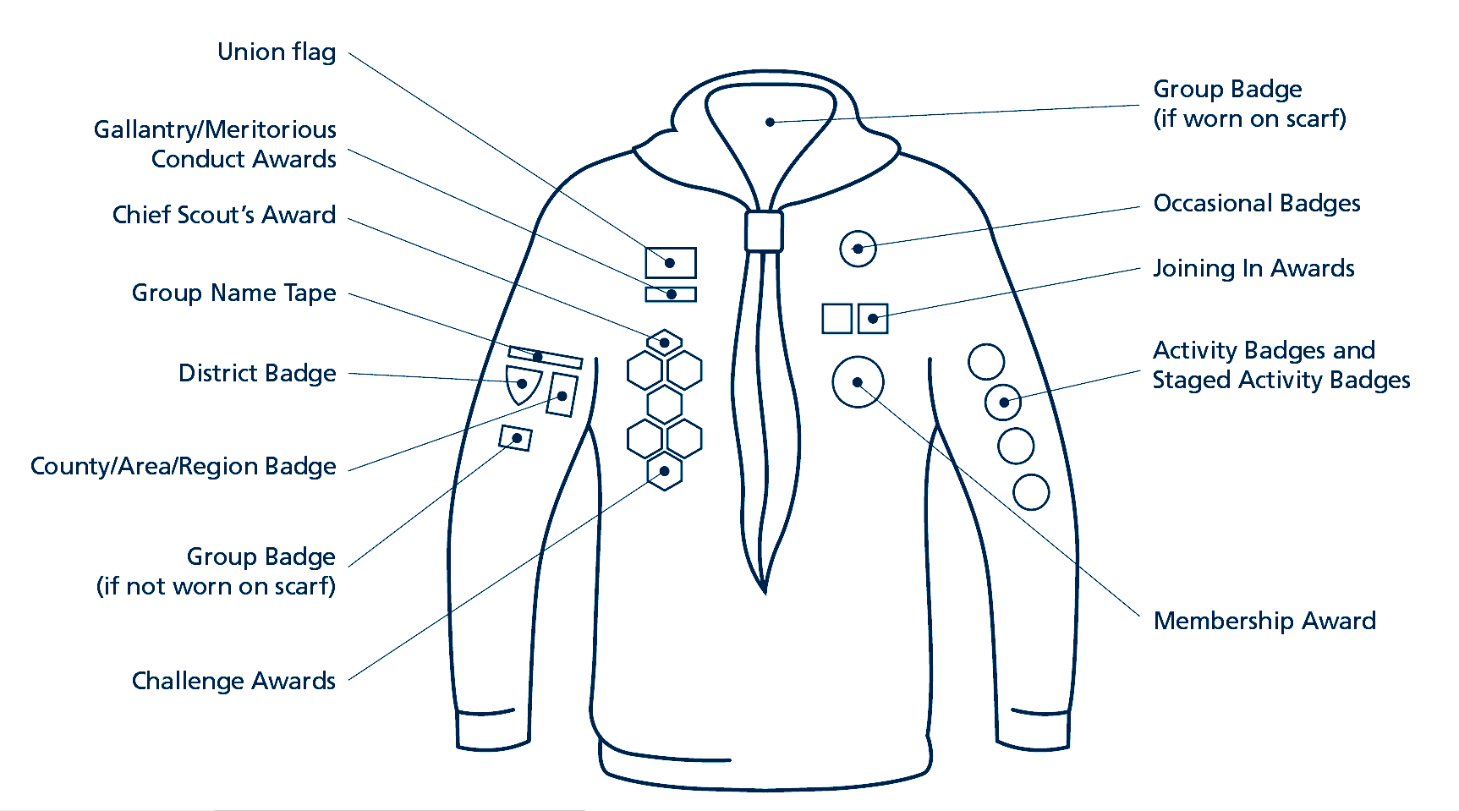
Make sure you talk to the Leaders about how you can earn badges, and use the diagram below to work out where they go on the uniform.
World Membership Badge
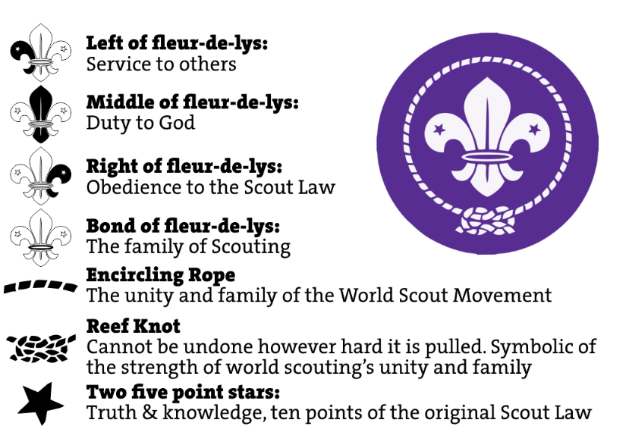
All Scouts wear a World Membership badge to show that we are all part of the same Scouting family. Can you spot it on the uniform of the other Cubs and Leaders?

Scout Handshake
All Scouts have a special way of greeting each other.
We shake hands using our ................................. hand.
Scout Motto
Scouts also have a motto, a short message to remember.
The Cub Scout Motto is:
.......................................................................................
Investiture Date
You are now ready to become a Cub Scout and will be invested on ...................................... at ...............................

