
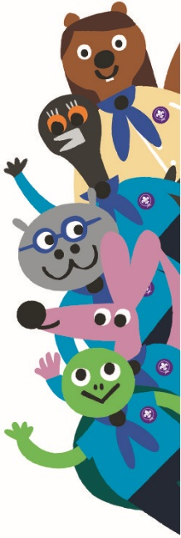Let’s find out all about becoming a Beaver Scout! We hope you will have lots of fun with us and in no time you will be ready to make your promise and become a Beaver Scout.
Our Scout Group
Beaver Scouts are the youngest members of the Scout family. In the United Kingdom, Scouts are split into different age groups:

Squirrels: 4 - 5 Explorers: 14 - 18
Beavers: 6 - 8 Young Leaders: 14 - 18
Cubs: 8 - 10½ Network: 18 - 25
Scouts: 10½ - 14 Leaders: 18+

When multiple sections join together, this is known as a Scout Group. There are many different Scout Groups around the world, each with a different name.
Our Scout Group is called .....................................................
To help tell different Scout Groups apart, each wears a different coloured neckerchief (which some Groups call a necker, neckie or scarf). Colour in the picture below to show what colour our Scout Group wears:

Our Beaver Colony
A group of Beavers is known as a Colony. Sometimes Colonies have their own special name, especially if there are more than one Colony in a Scout Group.
I am part of the ..........................................................Colony.
As Colonies can be quite big, they are often split into smaller teams known as Lodges.
I am in the .................................................................Lodge.
The people in charge of the Beaver Scout Colony are known as the Leaders. They volunteer their time to help keep you safe and make sure you have lots of fun.
In our Colony, the Leaders are called:
...............................................................................................
...............................................................................................
...............................................................................................
Our Colony also has a Beaver mascot which gets to go home with a Beaver Scout who has tried their best, been kind and helpful or done something special this week.
If you get to take our mascot home, make sure you have lots of fun and let the Leaders know what you get up to. At the end of the week you need to remember to bring them back so they can go on another adventure!
Our Beaver Mascot is called .................................................
Opening Ceremony
At the start of each meeting we take part in an Opening Ceremony. During this we:
...............................................................................................
...............................................................................................
...............................................................................................
...............................................................................................
Closing Ceremony
When it’s time to go home we do a Closing Ceremony. During this we:
...............................................................................................
...............................................................................................
...............................................................................................
...............................................................................................
At the Closing Ceremony we often give out badges, notices or letters and remind you of anything special you might need next week.
Once Beavers has finished make sure you stay in the hall until an adult has come to collect you. When you leave don’t forget to take your coat and anything you made at Beavers.
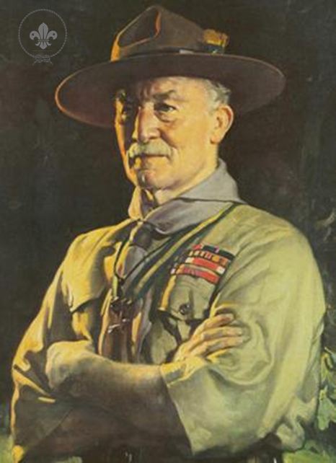A History of Scouting
In 1907, Lord Robert Baden-Powell held a camp on Brownsea Island to help teach a group of boys some survival and outdoor skills.

This camp helped him write a book called ‘Scouting for Boys’ which was used to start Scouts Groups all around the country.

Originally Scouting was designed only for boys aged 11-18. However, many younger brothers wanted to join Scouts which led to the creation of Cub Scouts in 1916 and Beaver Scouts in 1986.
For many years only boys were allowed to join Scouts. However, in 1991 Scouting started to accept girls into all sections.
Robert Baden-Powell (along with his wife Olave) also helped to set up a similar organisation for girls known as Girl Guiding.
Both Robert and Olave shared the same Birthday
(22nd February) which in Scouting is now known as Founders Day.
This day is a good time to think about all the other Scouts and Guides around the world – there are now around 28 million Scouts in 216 different countries!
The Beaver Colony
The beaver animal is about 70cm long with a thick coat of fur which keeps them warm and protects them from cold water. They are strong swimmers as their back legs have webbed toes and they have a scaly tail which acts as a rudder. Whilst they can’t breathe underwater, they can hold their breath for over 5 minutes!
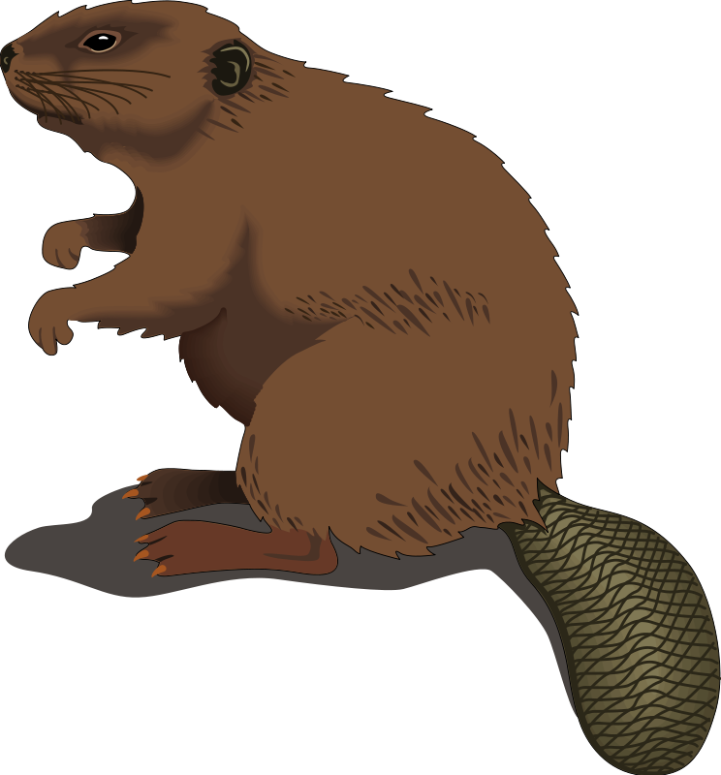
You can find beavers living wild in North America (especially Canada), Norway, Sweden and Russia. There are also a few in Britain too, but just in very special places.

Beaver families are good at working as a team. When a colony of beavers decide to make a new home they will build a dam across a small river so that it spreads out to become a pond. They then build a lodge where they live with their family, including baby beavers (known as ‘kits’).

Although beavers live in rivers and ponds, they do not catch fish. Instead they feed on bark, twigs, young leaves, grasses, nettles and the roots of water plants.

Use the space below to draw a picture of a beaver:

Making Your Promise
In order to become a Beaver Scout you must make your promise at a special ceremony called an Investiture.

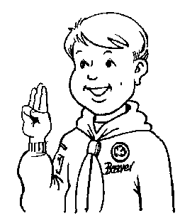You must learn the promise so that you can say it with your Beaver Scout friends when you are invested. You will then receive badges to wear on your uniform and the Group neckerchief.
During the investiture you will need to make the Scout sign. In your right hand, use your thumb to press down your little finger like the picture shows.

The Beaver Scout Promise

For Christians, Jews
and Sikhs
I promise to do my best
to be kind and helpful
and to love God.
For Hindus and Buddhists
I promise to do my best
to be kind and helpful
and to love my Dharma.
For Muslims
I promise to do my best
to be kind and helpful
and to love Allah.
For humanists,
atheists and those
with no defined faith
I promise to do my best
to be kind and helpful
and to love our world.
The Beaver Uniform
Each of the Scout sections wear a different uniform so
you can easily tell whether they are a Beaver, Cub, Scout or even a Leader. Once you have decided that you want
to become a REAL Beaver Scout you should buy a turquoise jumper ready for when you make your promise.
Badges
Once you have made your promise you can start to sew badges onto your uniform. There are a range of different badges you can be awarded. Some you will receive when you are invested, whilst others can earned at Colony meetings, special events (such as sleepovers) or worked towards at home.

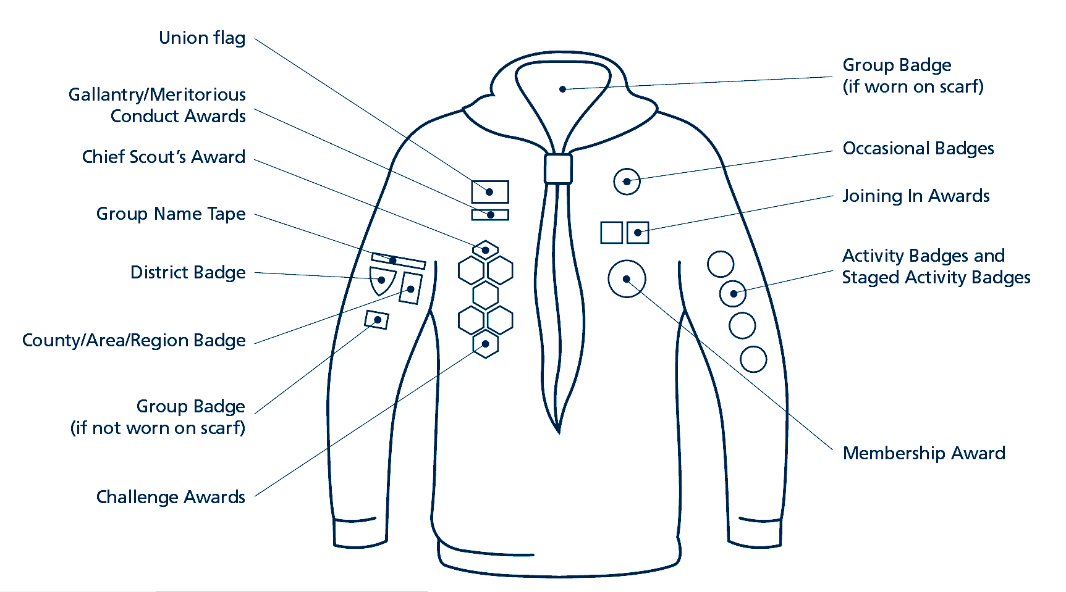Make sure you talk to the Leaders about how you can earn badges, and use the diagram below to work out where they go on the uniform.
World Membership Badge
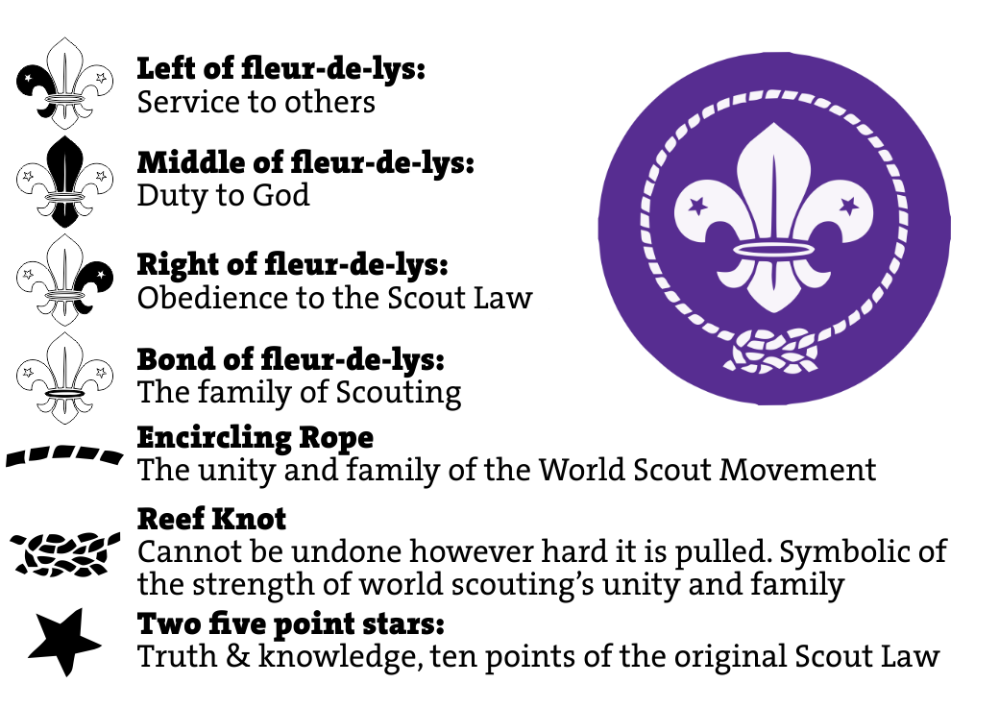All Scouts wear a World Membership badge to show that we are all part of the same Scouting family. Can you spot it on the uniform of the other Beavers and Leaders?

Scout Handshake
All Scouts have a special way of greeting each other.
We shake hands using our ................................. hand.
Scout Motto
Scouts also have a motto, a short message to remember.
The Beaver Scout Motto is:
.......................................................................................
Investiture Date
You are now ready to become a Beaver Scout and will be invested on ...................................... at ...............................

